## 

## **2024-2025 Frequently Asked Questions about the FAFSA**

## How are Contributors determined?  The student's or parent's answers will determine which contributors (if any) will be required to provide information.

**How are Contributors invited to the FAFSA?**

To invite a contributor, you will need their **Name, Date of Birth, Social Security Number, and Email address**. Please plan ahead and let them know the invitation is coming*. Encourage them to apply for the FSA ID and password in advance.*

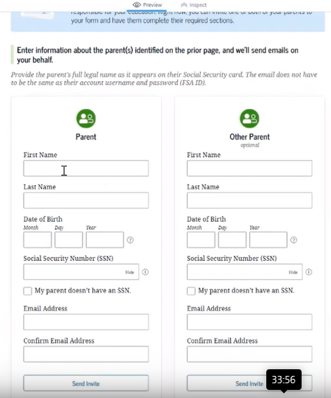

Contributors will have an opportunity to accept or reject the invitation. However, failure to participate or consent to having their information provided will result in your FAFSA being rejected.

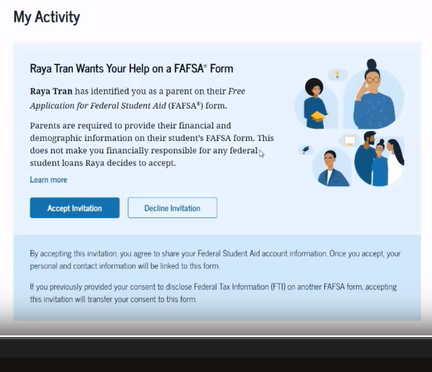

**What if my parents are divorced? Who is the contributor to my FAFSA?**   
Students that live with a single/divorced/widowed parent and receive most support from that parent, will report only one parent on the FAFSA.  
  
The parent included in the FAFSA as a contributor must be the parent that provides the greater portion of the student's financial support. If that primary parent is remarried, the income of that parent's spouse (stepparent) will also be required.

**What if my parents are not in the United States?**   
Your parents' citizenship status doesn't affect your eligibility for federal aid. They cannot create an FSA ID, but you can complete the FAFSA on paper and ask for their signatures. For FAFSA purposes, you must provide your parents' income, no matter where they reside.

**My parent remarried. Is the parent's spouse required to get an FSA ID as well?**   
If the parent you indicate on the FAFSA is the parent who remarried, it will depend on how they filed taxes. If they filed jointly, only one parent needs an FSA ID. If they filed separately, both parents would need their own FSA ID.

**Will parents and students need to create a new FSA ID if they have had an FSA ID in the past?**   
No. You can [retrieve your existing FSA ID](https://studentaid.gov/fsa-id/sign-in/retrieve-username) if you forgot your username and password.

**Why do I have to set up two-step verification for my StudentAid.gov Account?**   
Two-step verification, a form of multi-factor authentication (MFA), helps protect your StudentAid.gov account with additional protection from fraud.

**So each contributor needs a unique phone number or email for multi-factor authentication?**   
Yes! For example, a student and parent cannot use the same phone number for MFA.

**Do both parents need to create FSA ID or just one like before?**   
This depends on the family's situation. For example, if a student has married parents filing taxes separately, both parents will need to make an FSA ID.

**If a parent does not want to or refuses to create an FSA ID, is there an alternative for that parent to provide consent, such as mailing a wet signed consent page?**   
Starting 2024-25, a separate signature page will no longer exist. There are two alternative options for contributors to provide consent who do not want to or refuse to create an FSA ID:

1. The first example would be the student applying using the paper FAFSA and obtaining wet signatures from all contributors, including the parents, who also affirm their consent.
2. The other option is for the student completes their section and self-reports information for the parent section on the FAFSA form. When the student submits their FAFSA form without the parent's signature, it will be placed in rejected status by the FAFSA Processing System (FPS). The parent can then provide their signature and consent on a paper copy of the FAFSA Submission Summary. Now this method is not recommended due to complexity and increased processing time.

**What happens if I, as a student, or a spouse or parent, don't want to provide consent on the FAFSA?**   
If a student, spouse, or parent doesn't provide consent on the FAFSA, the Student Aid Index (SAI) will not be calculated, and the student will not be eligible for any federal aid.

**What if I had a low income and was not required to file taxes?**   
According to the [IRS tax year 2022, these are the thresholds by filing status](https://www.irs.gov/newsroom/who-needs-to-file-a-tax-return). If an independent student (and spouse, if married), or a parent of a dependent student, were not required to file a federal income tax return for 2022, then the student will automatically receive a Student Aid Index (SAI) equal to –1500. They still need to provide consent when submitting the FAFSA, so the IRS can confirm to Federal Student Aid (FSA) the student, parents, and spouse didn't file taxes.

**Will non-custodial parents be contributors if they have not claimed the child on their taxes?**   
Starting with the Simplified FAFSA, students will determine which parent to report based on which one provides the most financial support. It is ok if the parent or parents reported do not claim the student on their taxes. The reported parents will provide consent to transfer their taxes data even if they do not claim the student on their taxes.

**If parents that are remarried provide more support to the child than a biological parent, does the stepparent have to provide their taxes information?**   
Yes. If the parent providing more financial support is remarried, the stepparent's tax information is required.

**What if my parent or stepparent does not want to provide their tax information for my FAFSA?**   
Our Federal Aid Counselors can offer to talk directly with the parent or stepparent to explain why that information is needed and answer any questions, which sometimes puts them at ease about how their sensitive info will be used. However, we cannot provide tax advice.

**How do I report small business or farm value as assets on the FAFSA?**Independent students or parents are the best sources for this estimate; they can also consult their accountant or other financial professional if they have access to one to estimate the amounts to report.

**My parent is self-employed -- do they still need to say they own a business?**   
Being self-employed does end up showing business income on tax returns. But it depends on the type of work whether or not they will have to report any assets associated with their business.

**I – and/or my parents or spouse – amended our taxes. Will my Federal Tax Information (FTI) be transferred, or do I have to provide a 1040X later to the school?**   
Yes. Starting 2024-25, when the student, spouse, parent, and/or stepparent provide consent, the IRS's Federal Tax Information (FTI) will include the information from an amended tax return.

**Can I self-report my income on FAFSA?**   
After you provide consent on the FAFSA, if the IRS cannot transfer your Federal Tax Information (FTI) to your FAFSA application, the application will allow you to self-report it. Self-reporting one's tax information on the FAFSA does not override the requirement for each required contributor to provide consent on the FAFSA form. So two pieces - they need to provide consent, and we need to have their tax information, either directly from the IRS or self-reported manually on the FAFSA form.

**If a parent of a dependent student or an independent student is a non-filer and has zero wages, do they have to provide consent?**Any individual who is a contributor to the FAFSA application must provide consent. This includes parents, and independent students, regardless of their tax filing status. Generally, the parents of independent students are not contributors and would, therefore, not need to provide consent.

**What happens if a contributor provides consent but doesn't sign the application?**   
Starting 2024-25, there will be only two options for filing a FAFSA form: electronically, through [studentaid.gov](https://studentaid.gov/), or the option to file on paper which will also be available. However, once an application is started online, all parties must complete it online. So that means that if a signature is missing, the parent or the contributor that needs to complete their section and/or sign the application must obtain an FSA ID and get into the application and complete their section.   
  
There is no option to print a signature page any longer. For this reason, financial aid administrators will not be able to submit complete FAFSA forms because of the consent provision that all contributors must provide and sign.   
  
Students and parents will be required to have an FSA ID to complete the FAFSA application online. If they choose to mail a paper FAFSA, both will need to provide consent on the paper FAFSA, and both will need to provide wet signatures and mail the application to the Department of Education address on the paper application. This method is not recommended due to complexity and increased processing time.

**In what situations will there be a match with IRS, but IRS wouldn't provide information?**Fraud or identity theft are the most likely reasons for the IRS not providing tax information to the applicant or the contributor. If the contributor has been flagged by the IRS, possibly due to identity theft or a breach of some sort to their information, then the IRS response code will be IRS enabled to provide information.

**If a parent does not want to or refuses to create an FSA ID, is there an alternative for that parent to provide consent, such as mailing a wet signed consent page?**   
There is no longer a separate signature page, and there won't be a consent signature option on paper. There are two alternative options for contributors to provide consent who do not want to or refuse to create an FSA ID. One option is to submit a paper FAFSA form completed by all contributors and mailed to the Federal Student Aid. This method is not recommended due to complexity and increased processing time.

### Student Aid Index (SAI) & Pell Grant

**What is the Student Aid Index (SAI)?**   
SAI, or Student Aid Index, is replacing the term Expected Family Contribution, known as EFC. The SAI brings a change in the methodology used to determine aid.

* The SAI is a number used to determine eligibility for need-based aid. It is calculated using information the student (and contributors, if required) provides on the FAFSA form.
* The SAI will replace the Expected Family Contribution (EFC) starting in the 2024–25 award year.
* A student’s SAI can be a negative number down to –1500.

**Important**: Your federal award equals:

Need= Cost of Attendance (COA) –Student Aid Index (SAI) – Other Financial Assistance (OFA).

**What is the main difference between the SAI (starting FAFSA 2024-25) and EFC (used until FAFSA 2023-24)?**   
The Student Aid Index (SAI) represents a change in the methodology used to determine aid:

* Child support received will now count as an asset instead of income.
* Family farms and small businesses will now count as assets.
* The number of family members in college is no longer considered in the needs analysis formula, but it is still a required question on the FAFSA form.

Additional information on the SAI formulas can be found in the [2024-25 DRAFT Pell Eligibility and SAI Guide](https://fsapartners.ed.gov/sites/default/files/2022-11/202425DraftStudentAidIndexSAIandPellGrantEligibilityGuide.pdf).

**How is Pell Grant eligibility determined?**   
Maximum Pell Grant - Students may qualify for a maximum Pell Grant based on family size, adjusted gross income, poverty guidelines, and tax filing status. Students qualifying for a maximum Pell Grant will have a Student Aid Index (SAI) between –1500 and 0.  
  
Student Aid Index (SAI) - Students who don’t qualify for a maximum Pell Grant may still be eligible if their calculated SAI is less than the maximum Pell Grant award for the award year. The student’s Pell Grant award will be equal to the maximum Pell Grant for the award year minus their SAI.  
  
Minimum Pell Grant - Students whose SAI is greater than the maximum Pell Grant award for the award year may still be eligible for a Pell Grant based on family size, adjusted gross income, and poverty guidelines.

**What if I had a low income and was not required to file taxes?**   
According to the [IRS tax year 2022, these are the thresholds by filing status](https://www.irs.gov/newsroom/who-needs-to-file-a-tax-return). If parents of a dependent student or an independent student (and spouse, if married) were not required to file a federal income tax return for 2022, the student will automatically receive a Student Aid Index (SAI) equal to –1500.

**Why are Assets different on the FAFSA 2024-25?**   
For the 2024–25 award year, some financial information previously considered income will be considered as assets. Also, some information not requested previously, like the family’s small business, will no longer be excluded from asset reporting.

**If students get a negative SAI, will they get a higher Pell Grant?**   
Students with a negative or 0 SAI will be eligible for the maximum Pell Grant. The difference is that the negative -1500 SAI indicates the student has a higher need than the student with 0 SAI, being eligible for other grants, if available, like Federal Supplemental Educational Opportunity Grant (FSEOG).

**If the family size is manually adjusted, will the SAI only be calculated based on the size drawn from the taxes?**   
It will be based on the family size that the family entered, if different from the taxes. Students may have to provide additional information if selected for verification.

**What is the parallel between the 2024-25 Negative SAI and Pell Grant?**

| **Negative SAI** | **Pell Grant - Max/Min Determined by** |
| --- | --- |
| * As low as -1500 * Non-tax filers receive automatic -1500 SAI (when parents of dependent students or independent students and spouses are non-filers). | * AGI (if required to file a federal tax return) * Household size * Federal poverty guidelines |

**How will Pell Grant be awarded?**   
Pell grant will not be awarded per enrollment category any longer, but per amount of credits.

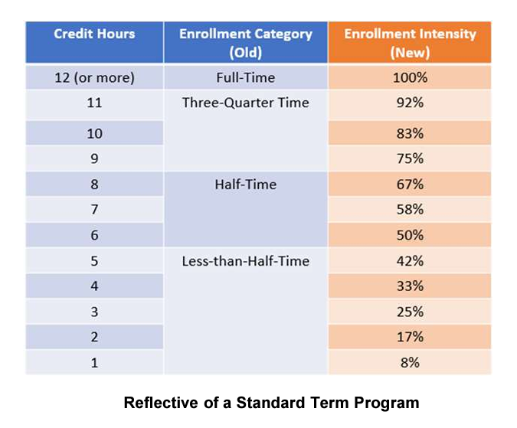

### Professional Judgement & Appeals

**What constitutes Unusual Circumstances on the FAFSA 2024-2025?**

* Unusual circumstances are when a student is unable to contact a parent or where contact with the parent poses a risk to the student.
* Starting in the 2024–2025 award year, applicants who indicate on their FAFSA form that they have unusual circumstances will be granted provisional independent status.
* Examples of unusual circumstances include human trafficking, legally granted refugee or asylum status, parental abandonment or estrangement, and student or parental incarceration.

What you need to know:

* Students with unusual circumstances will be granted provisional independent status and can complete the FAFSA form without providing parental information.
* Students with this provisional independent student status will receive an estimate of their federal student aid eligibility.
* A financial aid administrator will make the final determination of a student’s unusual circumstances based on the documentation that the student submits to the school, or the financial aid administrator may perform their own personal assessment.
* If a school approves a student’s unusual circumstances, their independent student status will remain as long as the student stays at the same school and their circumstances don’t change.
* All unusual circumstances must be documented.

**How can a student be considered an Independent for the FAFSA 2024-2025?**   
For the 2024–2025 award year, an independent student is one of the following:

* born before Jan. 1, 2001
* married (and not separated)
* a graduate or professional student
* a veteran
* a member of the armed forces
* an orphan
* a ward of the court
* Someone with legal dependents other than a spouse
* an emancipated minor
* someone who is unaccompanied and homeless or self-supporting and at risk of being homeless

**When should a student seek a dependency override? Only after they've decided on what school they are attending?**   
The dependency override is an important step in seeing how much financial aid a student will be eligible for. It is preferable for the student to pursue the override before making a decision so they can see accurate financial aid offers for each of their schools. They should contact any school they are interested in attending once the FAFSA is received to discuss their situation.

**What is Provisional Independence?**

* Students can receive provisional eligibility calculation.
* Students with unusual circumstances directed to independent student flow.
* Approved unusual circumstance determinations will carry forward.

**What are other type of Professional Judgement appeals students and families can request?**  
Please check your school’s financial aid webpages for more information about unusual circumstances or special circumstances. Many schools offer options for students who have a change in financial circumstances or a lifestyle change due to unusual circumstances.

Notice of Nondiscrimination: AACC is an equal opportunity, affirmative action, Title IX, ADA Title 504 compliant institution. Call Disability Support Services, 410-777-2306 or Maryland Relay 711, 72 hours in advance to request most accommodations. Requests for sign language interpreters, alternative format books or assistive technology require 30 days’ notice. For information on AACC’s compliance and complaints concerning sexual assault, sexual misconduct, discrimination or harassment, contact the federal compliance officer and Title IX coordinator at 410-777-1239, [complianceofficer@aacc.edu](mailto:complianceofficer@aacc.edu) or Maryland Relay 711.